Ideation Phase
Empathize & Discover

Date | 08 Febrauary 2026
Team ID | LTVIP2026TMIDS66040
Project Name | IntelliSQL: Intelligent SQL Querying with LLMs Using Gemini Pro
Maximum Marks | 4 Marks

Empathy Map Canvas:
An empathy map is a visual tool used to understand user behaviors, needs, and pain points. For IntelliSQL, it helps us analyze how users feel when interacting with databases and struggling with SQL query writing.

Understanding the user's perspective enables us to design IntelliSQL as an AI-powered natural language to SQL system using Gemini Pro LLM that simplifies database querying.

User Type: Student / Non-Technical User SAYS:
- 'I don’t know how to write complex SQL queries.'
- 'Database syntax is confusing.'

THINKS:
- There should be an easier way to get data.
- Writing joins and nested queries is difficult.

DOES:
- Searches online for SQL examples.
- Tries multiple times and gets syntax errors.

FEELS:
- Frustrated due to errors.
- Dependent on technical experts.

Problem Identified
Users struggle to convert natural language questions into accurate SQL queries due to lack of technical knowledge and schema understanding.

Proposed Solution – IntelliSQL
IntelliSQL leverages Gemini Pro LLM to convert natural language input into schema-aware SQL queries, validate them, execute them on the database, and present understandable results to the user.

Example:
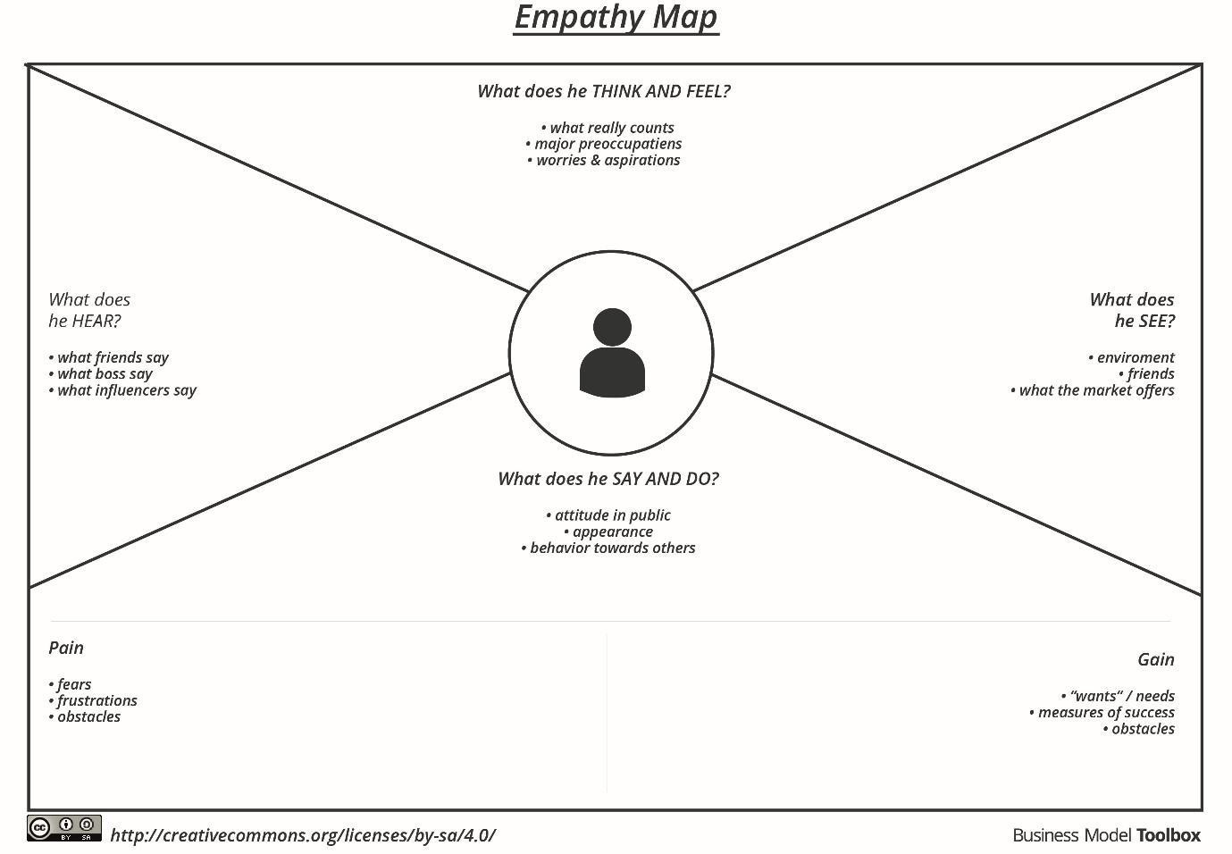

Reference: https://www.mural.co/templates/empathy-map-canvas

Example: Food Ordering & Delivery Application
